RC Car

**Description:**

In this project our group is going to build an RC Car from scratch using a ATmega328P microcontroller and a printed circuit board. The goal of this project is to be able to build a functioning radio controlled operated car using a PCB with minimal parts.

The RC car will be powered by a 9V power supply which will be connected to a L298N H-bridge motor driver, four 3V DC motors, an ATmega 328, and an NRF24L01 radio module. The H-bridge can take a 5V-35V voltage and has an on-board 5V voltage regulator, if the voltage from the power supply is less than 12V then we can use the onboard 5V input as an output to power the ATmega 328 which is what we will be doing. The H-bridge has a voltage drop of .7V at each input (2) for the connection of the motors, taking this into account we will have to supply an additional 1.4V to the H-Bridge to power the DC motors.

The H-Bridge will output 5V to power the ATmega 328, from here the NRF24L01 will be connected to the 3.3V Vout pin of the ATmega 328 to power the device. The NRF24L01 also has an onboard 5V voltage regulator. Our group will also build a remote controller to control the RC car, this will consist of a 7.4V-9V power supply, Arduino Uno/Nano, and a joystick. Firmware will be added onto both and is shown below.

**Areas of Responsibility:**

Keoni Sablan: RC Car Electrical circuit/components

Douglas Guillen: Remote control electrical circuit/PCB design

Mario Duenas: Firmware/ PCB design

Zack Iyaere: Firmware Remote control

**BOM**

|  |  |
| --- | --- |
| parts(data sheet) | Cost ($) |
| PCB | x |
| ATMega328P Microcontroller (already have): [amazon](https://www.amazon.com/Deegoo-ATmega328P-Microcontroller-Board-Arduino/dp/B07R9VWD39/ref=asc_df_B07R9VWD39/?tag=hyprod-20&linkCode=df0&hvadid=459728334703&hvpos=&hvnetw=g&hvrand=6705321426318699935&hvpone=&hvptwo=&hvqmt=&hvdev=c&hvdvcmdl=&hvlocint=&hvlocphy=9032010&hvtargid=pla-945070251730&psc=1)  [data sheet](https://ww1.microchip.com/downloads/en/DeviceDoc/Atmel-7810-Automotive-Microcontrollers-ATmega328P_Datasheet.pdf) | Provided by Lab |
| L298N H-Bridge: [datasheet](https://discord.com/channels/1014667238906789929/1014667239418515519/1019386833265770526)  [amazon](https://www.amazon.com/Qunqi-Controller-Module-Stepper-Arduino/dp/B014KMHSW6/ref=asc_df_B014KMHSW6/?tag=hyprod-20&linkCode=df0&hvadid=167139094796&hvpos=&hvnetw=g&hvrand=18441836055005901989&hvpone=&hvptwo=&hvqmt=&hvdev=c&hvdvcmdl=&hvlocint=&hvlocphy=9032010&hvtargid=pla-306436938191&psc=1) | $6.99 |
| NRF24 radio: [amazon](https://www.amazon.com/Wireless-Transceiver-Antenna-Compatible-nRF24L01/dp/B09J2LBZPT/ref=sxts_rp_s_a_1_0?content-id=amzn1.sym.eff26b9b-e255-411b-a40d-eccb21f93fe4%3Aamzn1.sym.eff26b9b-e255-411b-a40d-eccb21f93fe4&cv_ct_cx=nrf24l01&keywords=nrf24l01&pd_rd_i=B09J2LBZPT&pd_rd_r=f8e626b0-e2fd-45eb-a6b4-014ccfbef59e&pd_rd_w=ORdvE&pd_rd_wg=WaHm7&pf_rd_p=eff26b9b-e255-411b-a40d-eccb21f93fe4&pf_rd_r=4V1VPG41H1B79812PDYY&qid=1677709117&sprefix=NRF%2Caps%2C145&sr=1-1-5985efba-8948-4f09-9122-d605505c9d1e) | $6.89 |
| 4 DC geared motors + wheels:  [amazon](https://www.amazon.com/ApplianPar-Shaft-Gearbox-Plastic-Arduino/dp/B086D5M65M/ref=asc_df_B086D5M65M/?tag=hyprod-20&linkCode=df0&hvadid=459579282194&hvpos=&hvnetw=g&hvrand=5278461617360339489&hvpone=&hvptwo=&hvqmt=&hvdev=c&hvdvcmdl=&hvlocint=&hvlocphy=9032010&hvtargid=pla-995092589714&psc=1) | $9.55 |
| 2 Buck converters (up and down converters?) | $9.19 |
| Sliding switches (JS202011CQN) : [amazon](https://www.amazon.com/Components-JS202011CQN-Switch-Slide/dp/B00M1S3DOE)  [datasheet](https://www.ckswitches.com/media/1422/js.pdf) | $1.74 |
| Arduino Nano board  [Amazon Arduino](https://www.amazon.com/LAFVIN-Board-ATmega328P-Micro-Controller-Arduino/dp/B07G99NNXL/ref=sr_1_2_sspa?crid=1K1F6BH7UMPIA&keywords=arduino+nano&qid=1664566208&qu=eyJxc2MiOiI1LjAyIiwicXNhIjoiNC41MiIsInFzcCI6IjQuNDEifQ%3D%3D&sprefix=arduino+nano%2Caps%2C117&sr=8-2-spons&psc=1) | $24.99 |
| Voltage regulator  <https://www.digikey.com/en/products/detail/onsemi/LM317MTG/918507> | $0.78 |

**Block Diagram:**

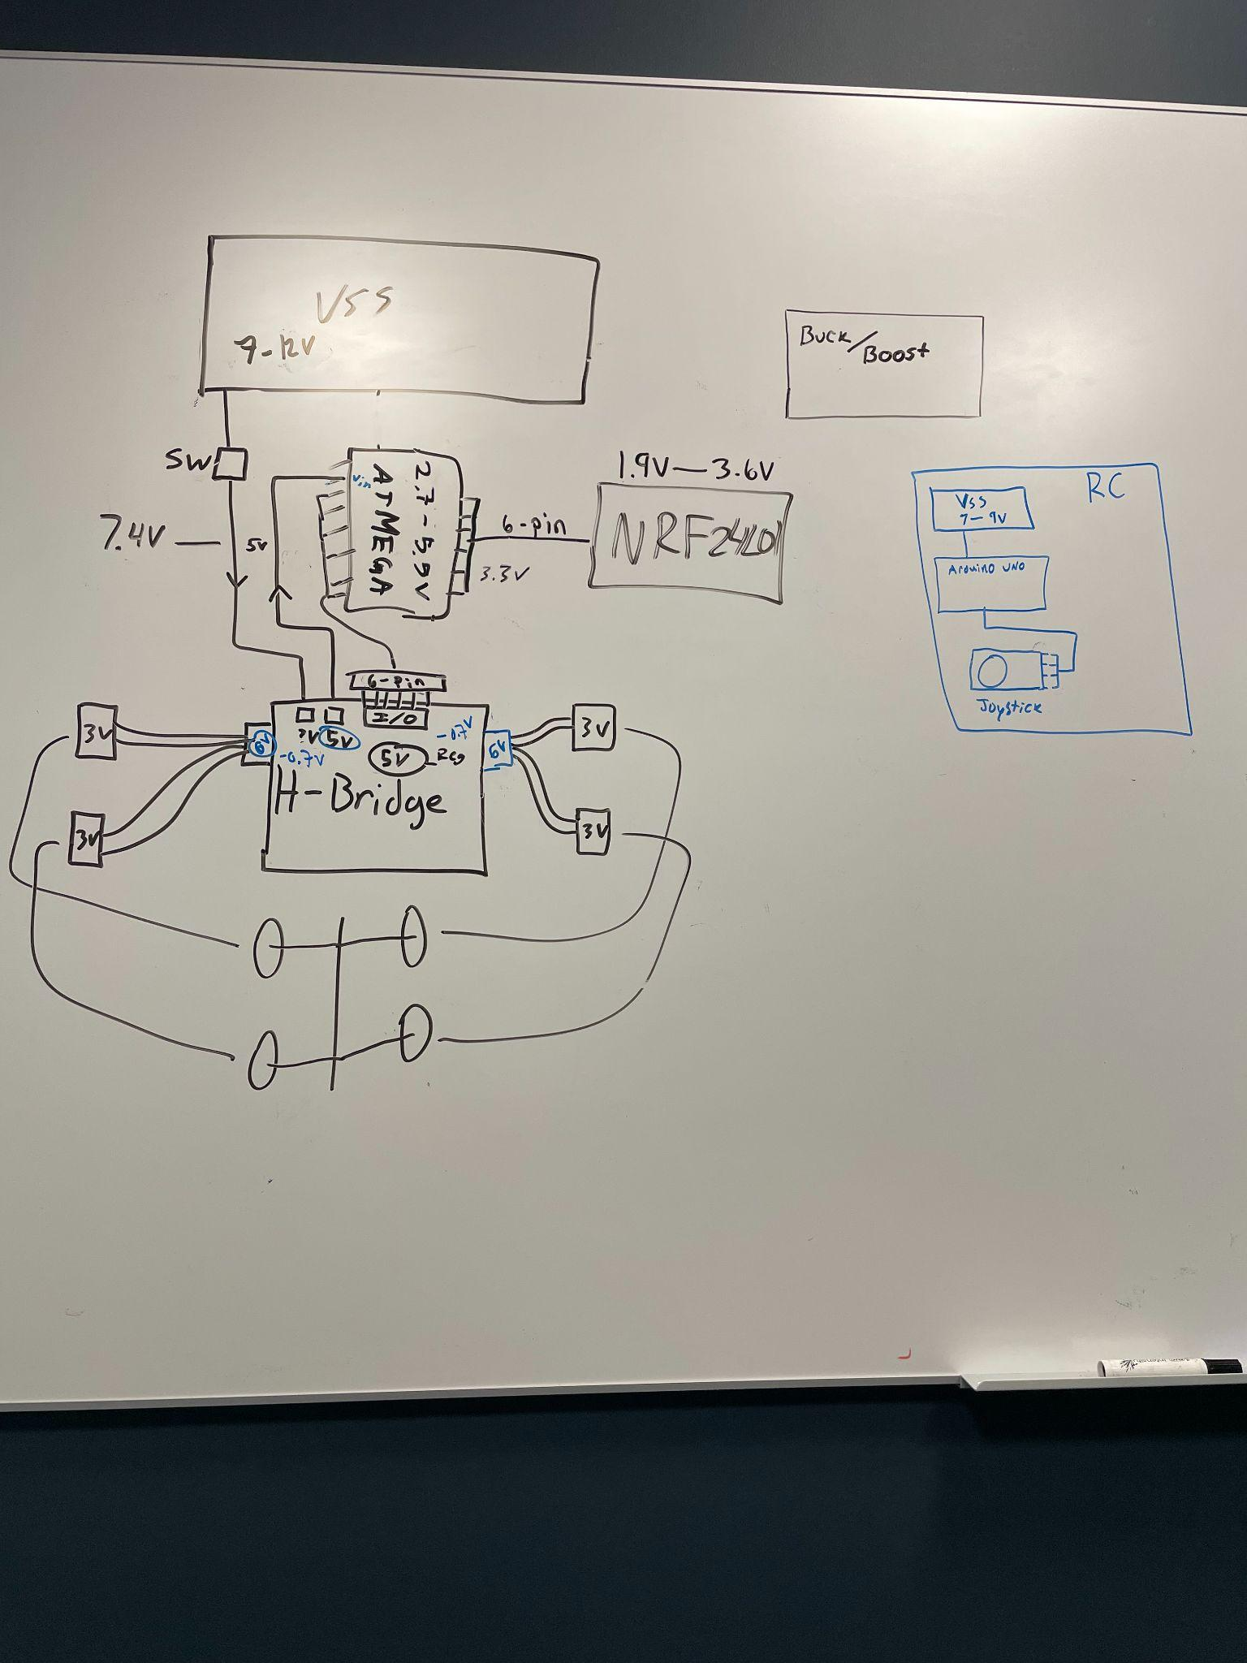

**Sources:**

* <https://lastminuteengineers.com/nrf24l01-arduino-wireless-communication/>
* [transmitter-receiver-setup-d73279](https://create.arduino.cc/projecthub/Arnov_Sharma_makes/arduino-based-nrf24-transmitter-receiver-setup-d73279)
* [https://create.arduino.cc/projecthub/Arnov_Sharma_makes/arduino-based-nrf24-t](https://create.arduino.cc/projecthub/Arnov_Sharma_makes/arduino-based-nrf24-transmitter-receiver-setup-d73279)
* <https://www.youtube.com/watch?v=Bs0QOjdiyOw>
* <https://maker.pro/pcb/projects/remote-control-car>
* [NRF24L01 RF Module Pinout, Arduino Examples, Applications, Features (microcontrollerslab.com)](https://microcontrollerslab.com/nrf24l01-wireless-module-pinout-examples-applications-features/#:~:text=nRF24L01%20is%20usable%20with%20all%20the%20microcontrollers%20and,their%20SPI%20pins%20according%20to%20the%20given%20circuit.)
* [SPI Communication Basics, Working, Types, Applications, Advantages (microcontrollerslab.com)](https://microcontrollerslab.com/introduction-to-spi-communication-protocol/)
* <https://www.theengineeringprojects.com/2017/08/introduction-to-atmega328.html>
* <https://docs.arduino.cc/resources/datasheets/A000066-datasheet.pdf>
* <https://www.arduino.cc/en/uploads/Main/ArduinoNanoManual23.pdf>
* <https://create.arduino.cc/projecthub/muhammad-aqib/nrf24l01-interfacing-with-arduino-wireless-communication-0c13d4>